Lab Manual 4

Syed Muhammad Ali Akbar

477723

#include <iostream>

using namespace std;

//Task 1

int main()

{

    int i;

    int sum;

    cin>>sum;

    for(i=1;i<11;i++)

    {

        sum+=i;

    }

    cout<<"Sum of first 10 numbers is: " <<sum<<endl;

   return 0;

}

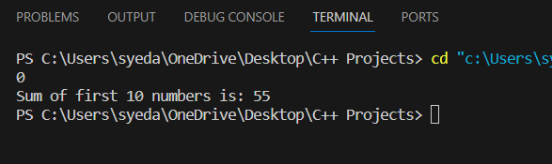

//Task 2

int main()

{

    int num;

    cout<<"Enter the number you want table for: "<<endl;

    cin>>num;

    int i;

    for(i=1;i<11;i++)

    {

        cout<<num<<" x "<<i<<" = "<<num\*i<<endl;

    }

}

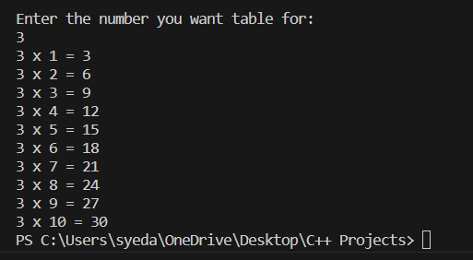

//Task 3

int main()

{

    int num;

    cout<<"Enter the number to take factorial of: "<<endl;

    cin>>num;

    int i;

    int fac=num;

    for(i=(num-1);i>0;i--)

    {

        fac\*=i;

    }

    cout<<"Factorial is "<<fac<<endl;

    return 0;

}

//Task 4

int main()

{

    int a;

    int b;

    int d;

    int nterm;

    cout<<"Enter First two numbers of sequence : ";

    cin>>a>>b;

    int ran;

    cout<<" Enter range "<<endl;

    cin>>ran;

    for(d=0;d<ran;d++)

    {

        if(d==0)

        {

            cout<<a;

            continue;

        }

        else if(d==1)

        {

            cout<<b;

            continue;

        }

        nterm = a +b;

        a=b;

        b=nterm;

        cout<<nterm;

    }

}

